|  |  |
| --- | --- |
| **Ex. 1** | **PYTHON IN INTERACTIVE AND SCRIPT MODE** |
| **Date: 22.01.24** | |
|  | |

**Aim:**

To explore the use of Python in the interactive and script modes in Linux.

**Interactive Mode Exercises:**

1. Execute the following in interactive mode:

$$width=17$$

$$height=12.0$$

$$delimiter='a'$$

Execute each of the following expressions and write the value of the expression and the type of the values obtained:

$${width}/2$$

$${width}/{2.0}$$

$${height}/3$$

$$1+2∗5$$

$$delimiter∗5$$

**Screenshot:**

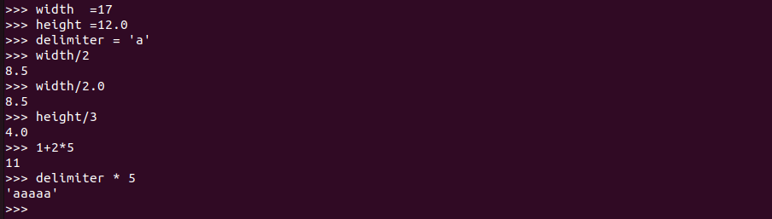

1. Use the Python interpreter as a calculator to answer the following:
   1. The volume of a sphere with radius $r$ is $\frac{4}{3}πr^{3}$. What is the volume of a sphere with radius 5?
   2. Suppose the cover price of a book is $24.95, but bookstores get a 40% discount. Shipping costs $3 for the first copy and 75 cents for each additional copy. What is the total wholesale cost for 60 copies?

**Screenshot:**

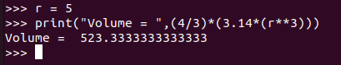

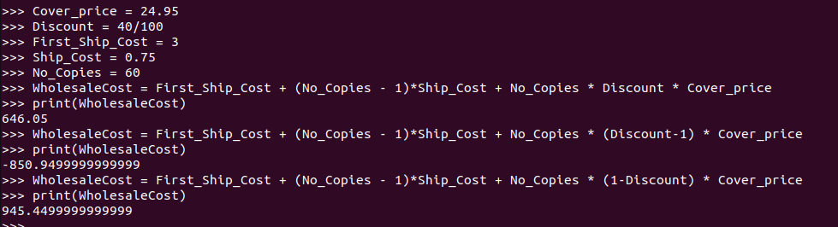

**Script Mode Exercises:**

1. Given the unit price of a product and the quantity of the product sold, find the total sale, using Python in script mode.

**Algorithm:**

Step 1: Get the unit price and quantity of a product from the user.

Step 2: Calculate the total sale by multiplying the unit price with the quantity of the product.

Step 3: Display the result:

**Program:**

**Screenshot of Output:**

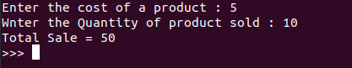

1. Write a program (script mode) to get two integers from a user, store them in variables $a$ and $b,$ and evaluate the following expression:

$$c=\frac{{\left(a+b\right)}^{2}+10}{a×b}$$

**Algorithm:**

**Step – 1:** Get the inputs required (a,b)

**Step – 2:** Equate the Variables given by the user in the expression

**Step – 3:** Display the output of the equation to the user

**Program:**

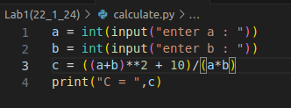

**Screenshot of Output:**



**Result:**

Thus, the use of python in the interactive mode and the script mode has been explored.